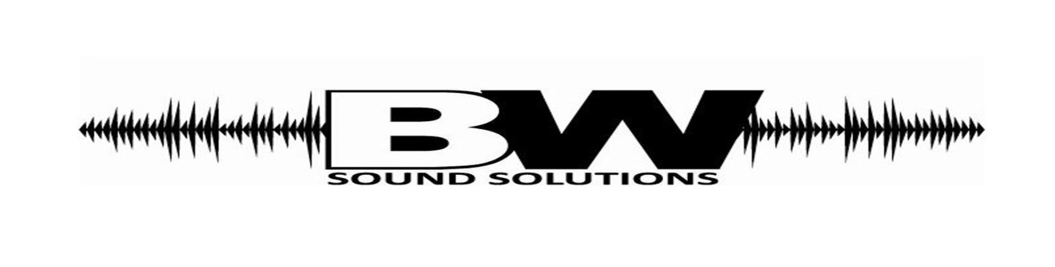
WESTERN BROWN GRADUATION DVD ORDER FORM
BW Sound Solutions will be creating Graduation DVD’s again this year.
To order your copies of this DVD please make checks payable to:
Brian Watkins
23 WEST RUBY AVE. WILMINGTON, OHIO 45177
Order must be paid in full by date of graduation.
DVD’s are $25.00 (This includes packaging and shipping)
Please fill out the bottom attachment and mail to BW Sound Solutions or see us during graduation.
BW Sound Solutions in not affiliated with Western Brown School District.
BW Sound Solutions will also be accepting credit card payments again this year!! (A $1.00 fee will be assessed for credit card payments per DVD)
*PLEASE ALLOW 6-8 WEEKS FOR DELIVERY*
If you have any questions please contact Brian Watkins 937-725-2563 or Chasity Watkins 937-725-4085
------------------------------------------------------------------------------------------------------------------------------------------

Name________________________________________________________________________________
Address ______________________________________________________________________________
City______________________________State__________________Zip Code______________________
Phone Number ______________________________Number of DVD’s____________________________

